Advanced Diploma in Mental Health and Wellbeing Coaching

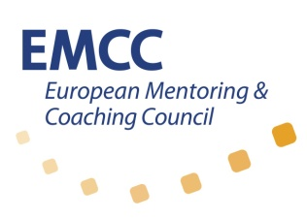
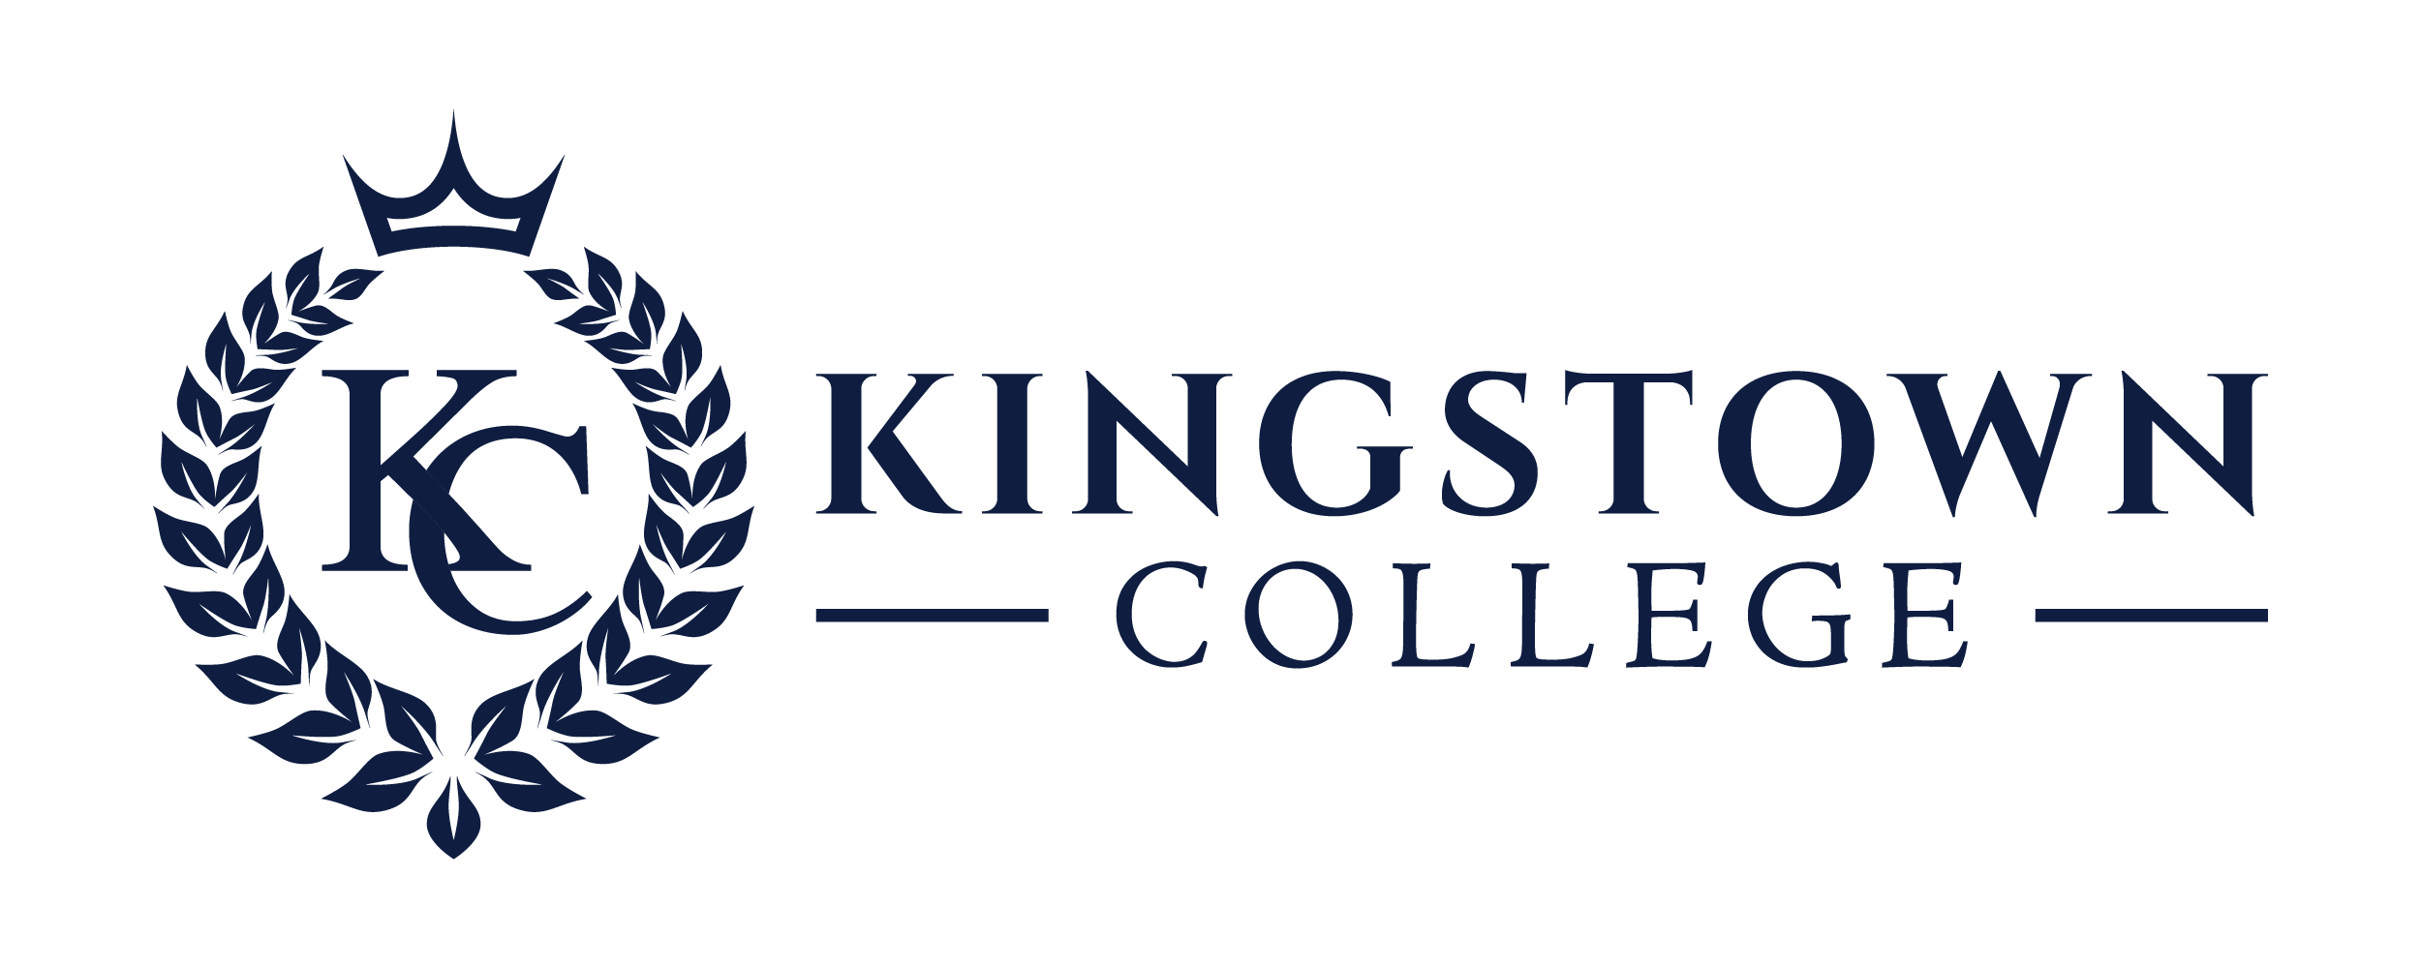

Price: £2,200

Workshop Dates. 10am - 4pm
Module 1: 28th & 29 Sept 2023
Module 2: 26th & 27th Oct 2023
Module 3: 23rd & 24th Nov 2023
Learning Review: 8th Dec 2023

Module 4: 18th & 19th Jan 2024
Assignment deadline 1:
19th Jan 2024
Module 5: 15th & 16th Feb 2024
Module 6: 14th & 15th March 2024
Observed Coaching Session: 25th & 26th March 2024

Assignment deadline 2:
12th April 2024

NB: Options available for Foundation and Certificate level

FULL ATTENDANCE IS REQUIRED

Location:
This course will be delivered virtually via zoom.
Enquiries: workwise@mindwisenv.org

This training programme is an excellent and unique opportunity to train in the area of Mental Health and Wellbeing Coaching. Designed for those practicing in mental health and associated areas, this course will equip you with skills to diversify your practice while learning techniques that can powerfully benefit your client on their journey of recovery to discovery.

How will this course benefit you?
- You will learn cutting edge coaching principles, tools and techniques
- Market research conducted by Mindwise has shown that 98% of surveyed stakeholders within the social care community believe MHWB coaching to be a good fit with their overall strategic direction.
- Development of Reflective Practice
- Ability to analyse problems in a systematic matter and apply critical judgement and competence to complex and demanding situations
Who is this course for?
- Mental Health practitioners such as therapists and counsellors
- Personal Development Professionals such as current life coaches, social workers, HR Professionals/wellbeing champions
- Psychologists and those working in the allied professional fields
- Those with experience of working within the field of mental health

Why Mental Health and Wellbeing Coaching?
Coaching is one of the fastest growing professions today and is widely accepted as a powerful resource for personal development. Drawing upon the coaching specialism of Kingstown College, MindWise have used their considerable expertise within the mental health field to develop a new flexible, innovative and creative model reflecting the changing needs of the delivery of mental health services today. We have achieved this by developing a 21st Century Model of practice which adapts coaching methods, tools and practices for mental health practitioners, enabling them to support their clients in their journey of recovery and discovery through coaching.
Market research conducted by MindWise, strongly supports the idea that Mental Health and Wellbeing coaches are of value to employers in health and social care services. 100% of stakeholders surveyed believed that coaching has a place within a 21st Century approach to the delivery of mental health and wellbeing services. 98% of these stakeholders confirmed that Mental Health and Wellbeing coaching is a good fit with their overall strategic direction.
The overall aim of this course is to produce competent, effective and informed practitioners who are capable of providing a first rate service to a range of clients with complex needs. The students will learn cutting edge coaching principles, tools and techniques together with focused experiential leaning with the multi-faceted concept of Recovery.

Why join this Training programme?
This programme will be run by trained facilitators from Kingstown College and MindWise, who are highly experienced in the mental health field and life coaching, and leaders in the developing area of Mental Health and Wellbeing Coaching.
These facilitators create a vibrant and fascinating learning experience, focusing on mindfulness, CBT practices, positive psychology (focusing on what it means to live a fulfilling life), and of course coaching tools and skills.

Who is this course for?
- Individuals who currently practice in mental health and social work settings who wish to practice as an accredited mental health and wellbeing coach.
- Current life coaches who wish to develop their skill set to work in a mental health setting are also ideal candidates for this training programme.
- Organisations that employ individuals in roles that address mental health issues within the workplace may be particularly interested in the further professional development of their employees that this training and qualification programme offers.

Course outline
In developing this qualification, we combined Kingstown College’s cutting-edge coaching principles, tools and focused experiential learning with the multi-faceted concept of Recovery, to develop a unique coaching model for mental health. The aim is to enable mental health and wellbeing practitioners to use this innovative and dynamic approach to support their clients in a journey of recovery and discovery through coaching.

Module 1
In the first module, students are introduced to Mental Health and Wellbeing Coaching and the concepts of Recovery and Discovery as they relate to this branch of coaching. Students learn how to structure a professional coaching session using core coaching tools and other concepts such as appreciative inquiry and feed forward.
Module 2
In the next module (Module 2), students look at several coaching techniques and interventions that help create new insights for their client. The student develops their own personal coaching style while studying associated areas such as the elements and values of a person and solution-focused coaching.
Module 3
In Module 3, we step back a little to examine the 3-step coaching technique, before we look at how to use our core coaching skills in a little more depth. Students also look at concepts such as commitment, motivational interviewing and belief systems and how they relate to the coaching process. We discuss the core competencies of a Mental Health and Wellbeing Coach and the use of these competencies in a good coaching session.
Module 4
In Module 4 students are presented with the fundamental concepts of the Recovery Approach and recovery-specific tools such as WRAP®. The application of the recovery approach to mental health and wellbeing coaching is discussed as well as coaching for resilience where students learn how to use some resilience-building coaching tools. Students are also introduced to conflict coaching and some of the related tools.
Module 5
In Module 5, we discuss coaching from a Positive Psychology and Cognitive Behavioural perspective and examine how some of the associated tools can be used in coaching. We examine some wellbeing coaching tools used in a Positive Diagnostic System and learn to apply them to mental health and wellbeing coaching.
Module 6
In Module 6, we explore the Life and Career Planning Coaching Model, the concept of Single/Double and Triple Loop Learning and Transformational Coaching. At this point of the course we also look at the importance of Mentoring and Supervision for a Coaching Professional and discuss the EMCC Code of Ethics.

How to Apply
Complete online enrolment form https://forms.office.com/e/e13CwgE1Nt

